
  HCS LIBRARY NEWS   HCS LIBRARY NEWS   HCS LIBRARY NEWS   HCS LIBRARY NEWS  

First years get ‘Booked Up’
Christmas is nearly here, and we hope many of you are enjoying some of the new books that have been pouring into the Library this term.

Don’t forget - you may borrow books over the Christmas holidays .
If you already have a library book and would like to keep it over the holiday please remember to renew it; please return your books if you don’t want them any more.
The Librarians at HCS are Mrs. Ayers-Nelson and Ms Adamson, who job share the week. If we are not around you may leave a message at the Staffroom in Old Deanery. Keep an eye on the Opening Times which are always posted on the door. Any changes will be written up and highlighted.

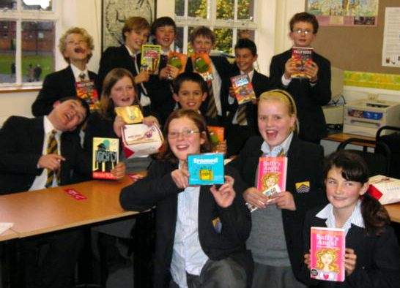
Autumn Term 2007
Autumn Term 2007

First year pupils with their early Christmas presents—new Booked Up books! Kath, Ben, Katie-Louise, Dan, Lucas, Greg, Jake, Charles, Alice, Charlie, Will and Minette.

This year is the National Year of Reading. To celebrate, every child in the country starting secondary school has had the opportunity to choose a free book. ‘Booked up’ is a scheme sponsored by the government and Booktrust.
In September, everyone in year 7 came into the Library during an English lesson to get ‘Booked Up’. The free books arrived in November and we hope you've all had a chance to read the one you picked.
Lauren Jones (1S) and Charlotte Abraham (1T) are in Mrs. Curry’s class. Lauren selected ‘Dream On’ by Bali Rai: “I chose this book because I like football —it’s really good and I recommend it to anyone who likes football. Getting a free book is a really good idea”. Charlotte’s choice was ‘Evil Inventions’ —“It’s a good book, very funny and gory; the best bit is the beheading machine!”
Next term, as a part of our own celebrations for the Year of Reading, we plan to hold ‘Book Swops’ where we can all swop the books around and read a different one. Make sure you join-in too!!
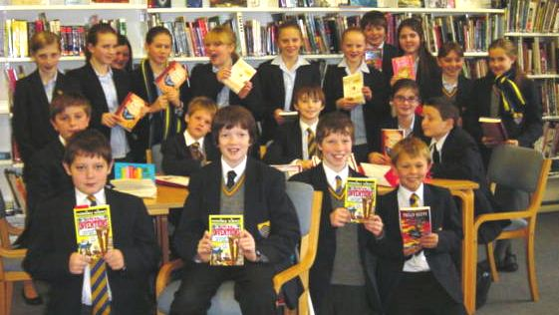

Mrs Tucker’s class and their early Christmas presents!

National year of reading!

Our celebrations in school are running in the Spring term, January to Easter – just the time to curl up with a good book!

We hope everyone will be able to have a reading book with them to read
In tutor time ….. In English lessons ….. In spare moments at the beginning and ends of lessons ….. At home!

Tutors will be able to visit the library with their forms, or have a box of books in tutor time. We hope to hold Book Swops and run the Reading Challenge again.
We are thinking of getting a travelling bookshop in…. if there are any volunteers out there willing to help running it..??!
All ideas considered – do let us know if you have any good ideas about fun things to do.

Do support us, and let us know if you can help!

Book Club
If you enjoy books and you want to tell other people about what you’ve been reading, why not join Book Club?
There’s always lots of lively discussion —so far this term we’ve read ghost and horror stories, adventure and spy stories, and historical fiction. There’s a lot planned for next term too (Christmas holiday books in January, romance in February…) and we will be shadowing the Carnegie shortlist. All this and chocolate biscuits for brain energy!
Book Club takes place once a month in the Library. 1st and 2nd year Book Club meets during lunch-break on the first Thursday of the month at 1.20pm. This is a popular and friendly club so make sure you get there early to claim your chocolate biscuit!

The Book Club Christmas party—there are so many of you we had to hold TWO parties!
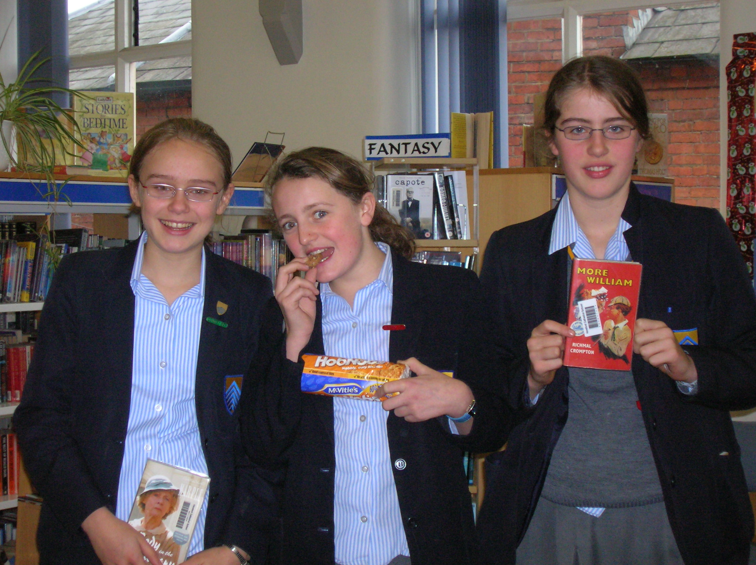

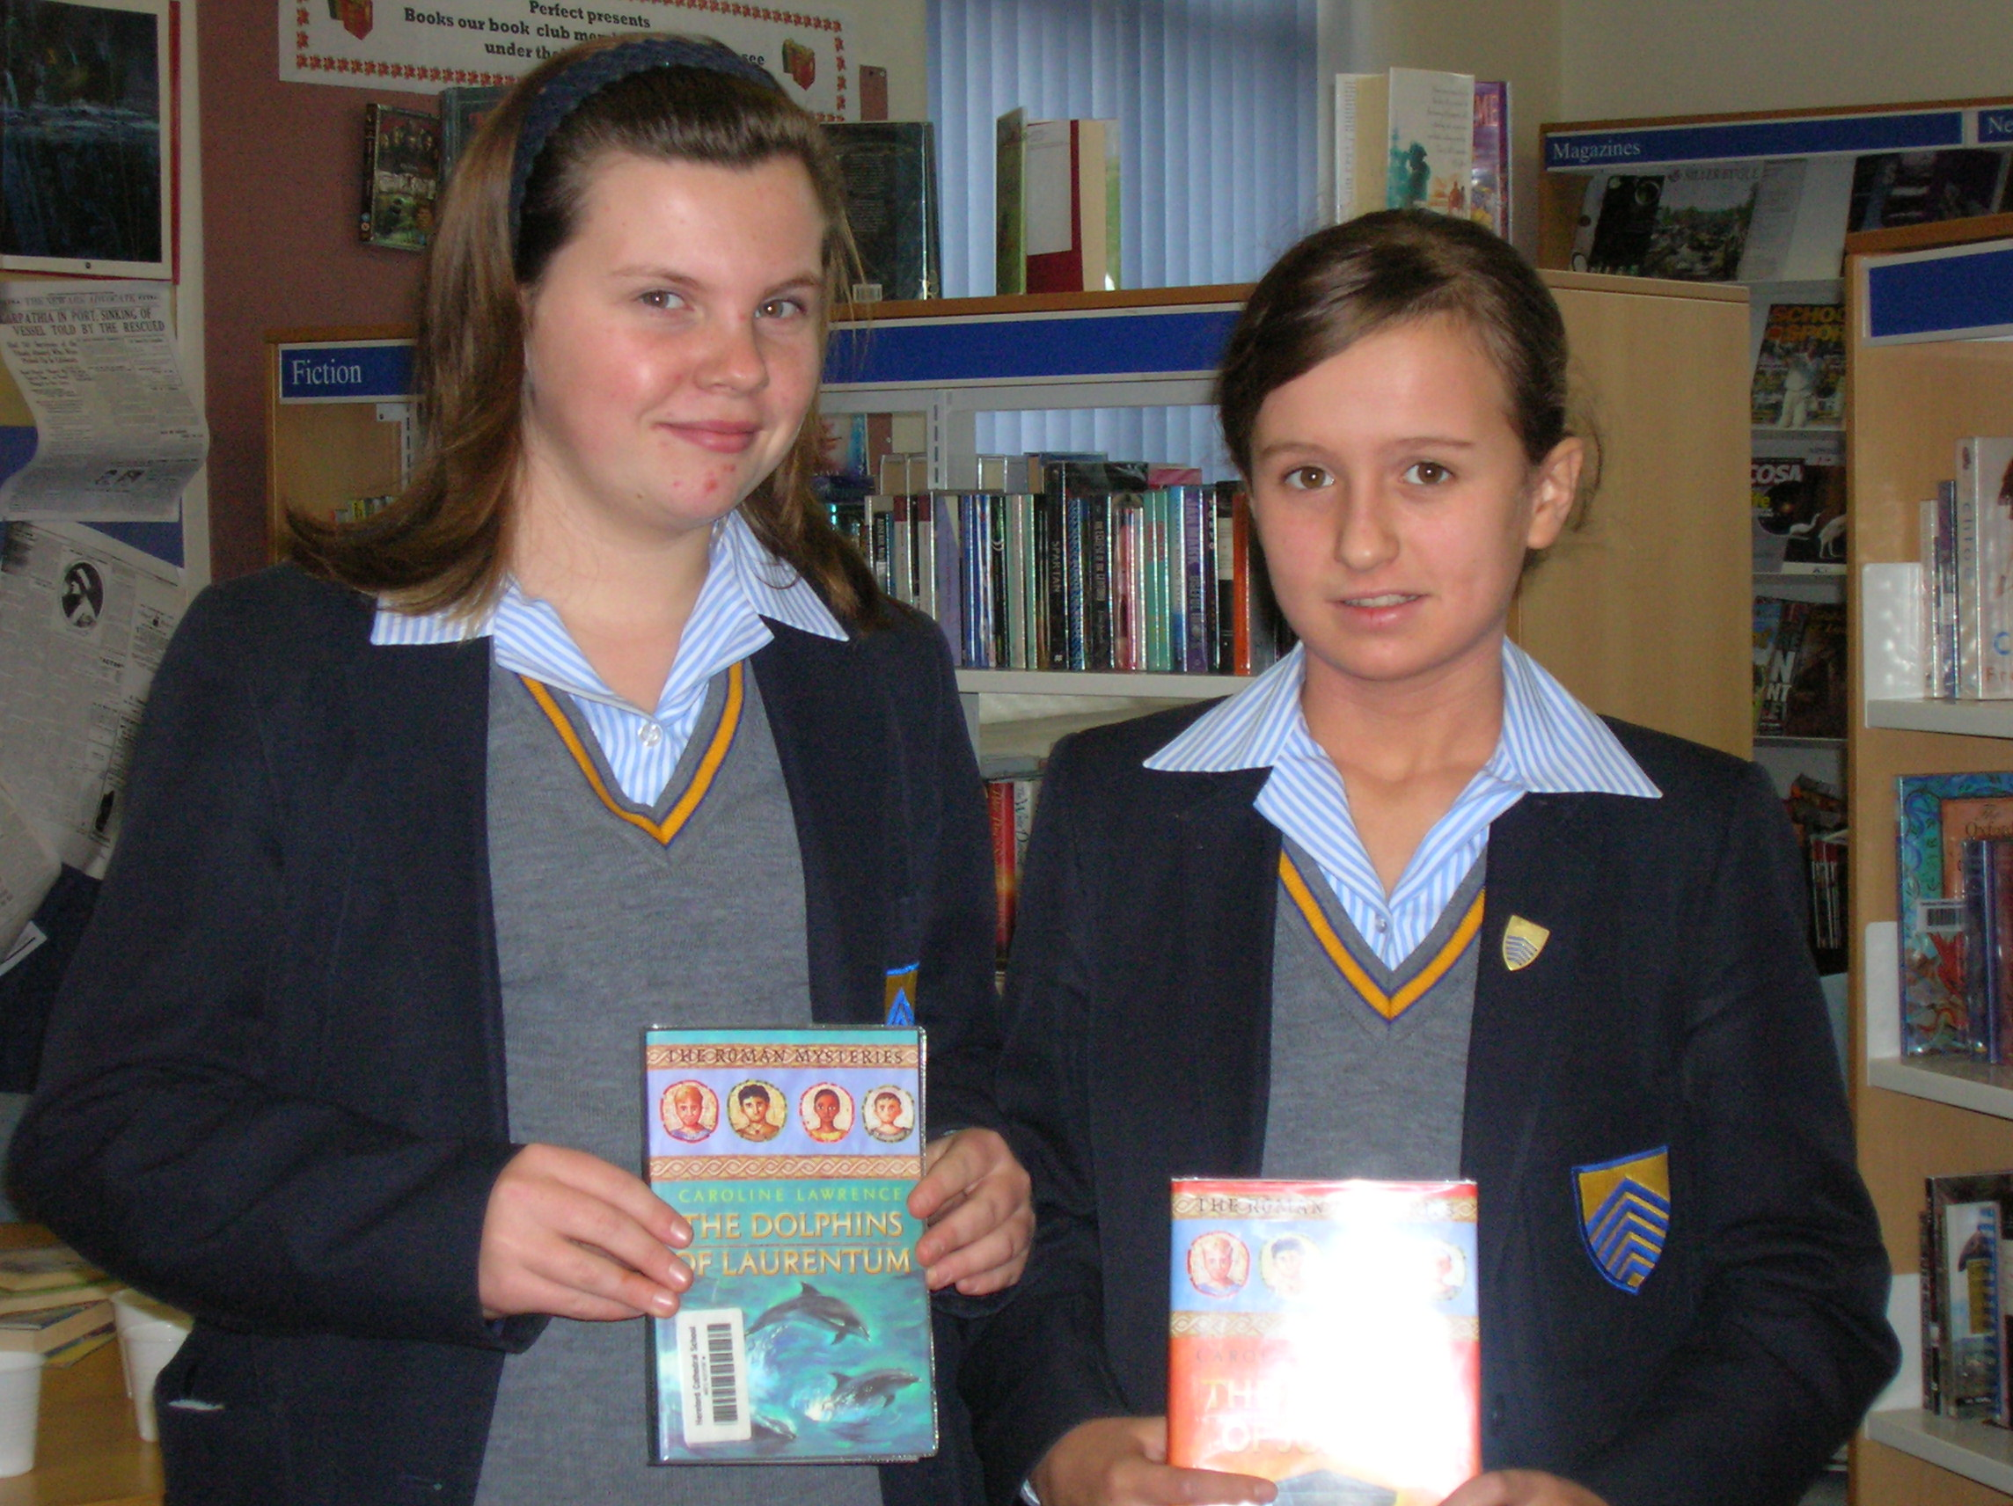
Beth, Sophie and Isabella love books and biscuits!

.
The Book Club Christmas party—there are so many of you we had to hold TWO parties!
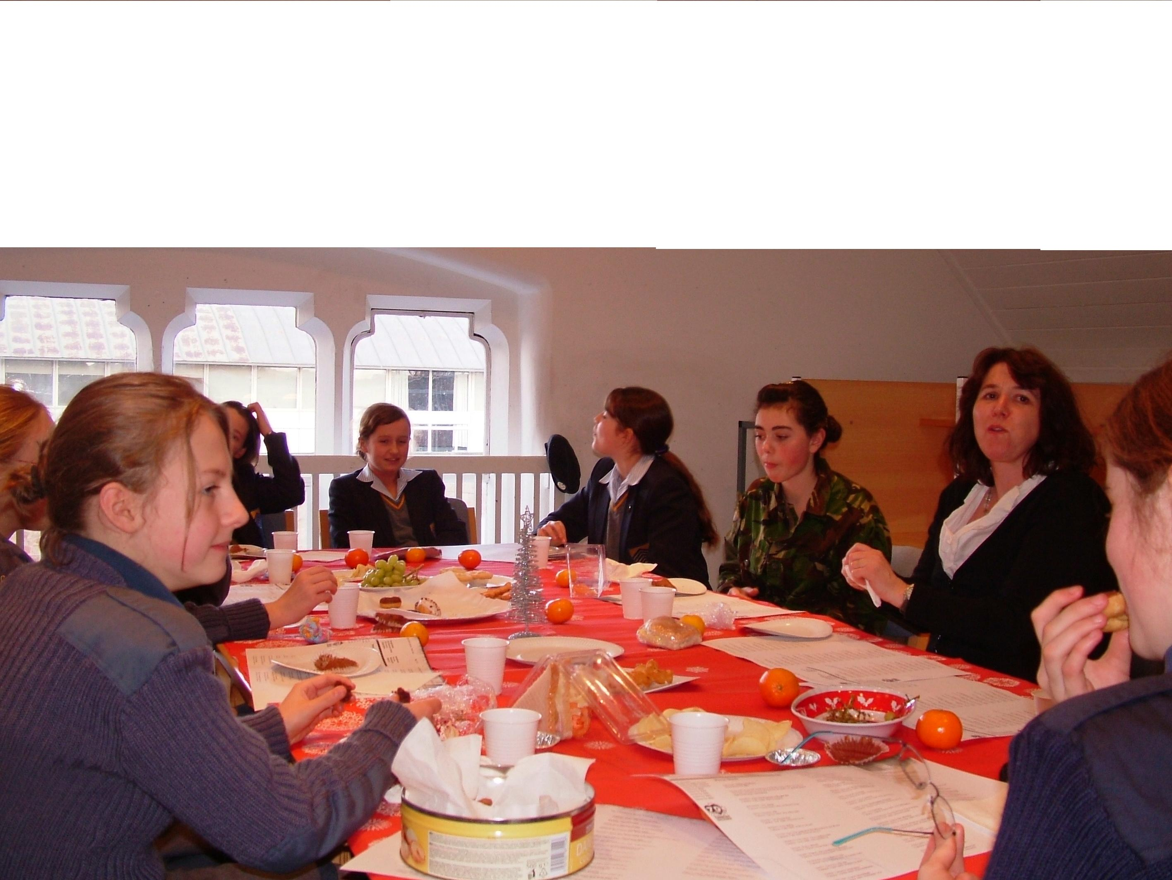
The Book Club Christmas party—there are so many of you we had to hold TWO parties!

Charlotte and Lucy are keen members of the 1st and 2nd Year Book Club

From next term, 3rd and 4th Year Book Club will meet after school on the first Monday of the month, so if you have not been able to come so far this year we hope you will find this more convenient
The Book Club Christmas party—there are so many of you we had to hold TWO parties!

Teachers oppose pupils

“This house would abolish school uniform” was defeated in a lively debate in the library on 27 November. Mrs Price and Mrs Wall faced Xander Drury (4C) and Will Thorman (L6C).

